**Insurance Claim Data Analysis – Report**

**Overview of Data**

* In the columns Vehicle Model (98) and Operation Assign Date (31) is the missing values.
* Removed the missing values rows to make the data ready for analysis.

**Column Description**

* **Vehicle Make Year:** Year the vehicle was manufactured
* **Vehicle Make:** Brand of the vehicle (e.g., DODGE, Mahindra)
* **Vehicle Model:** Specific model (e.g., CHARGER, Scorpio DC)
* **Claim Reg Date:** Date and time the claim was registered
* **Accident Place:** Location of the accident
* **Operation Assign Date:** Date and time the operation was assigned
* **Portal_OtherAmt:** Additional costs not covered under specific categories
* **Portal_PartProviderAmt:** Amount charged by part providers
* **Portal_WorkShopAmt:** Workshop repair charges
* **Total:** Overall claim amount.
* **Time Difference:** Claim Reg Date – Operation Assign Date.

**Basic Statistics**

* Model Make Year Ranges from 1998 to 2025 in the Data.
* Other Amount - minimum value is 0, maximum value is 15457, the mean is 143 and standard deviation is 372. Possibly the maximum value is outlier since the mean value is comparatively less, ie, which means Other Amount contain more small values including 0 and there are some extend of outliers.
* Parts Provider Amount – Minimum value is 0, maximum value is 184,285. The mean is 5781 and standard deviation is 7080 which is higher comparing the Other Amount. This means there is high variability in the values. 25% of values are less than 1582, 50% of values are less than 3863. And extremely high amount also shown in the data.
* Workshop Amount – minimum value is 0, maximum is 300,000 with mean value of 3023 and standard deviation 4139. There is variations in the data. 25% values are less than 1444, 50% values are less than 2200 and there are extremely high values in the data.
* Total Claim Amount – minimum value is 100, maximum value is 300,000. The mean is 8939 with standard deviation of 9340. There is high variation in Total Amount. 50% of values are less than 6638 and extremely high values are also there.
* Time Difference – Column to understand how many days to complete the process of Claim Registration and Operation Dates. Most of the Vehicles are done within one day. Also there are data with high number of days like 1869.

**Univariate Analysis**

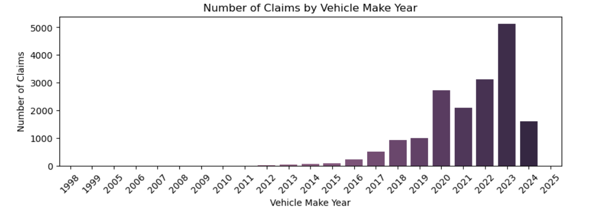

* Checked the Model Make Year.
* From 2020 to 2024 Models are mostly Claimed the Insurance.

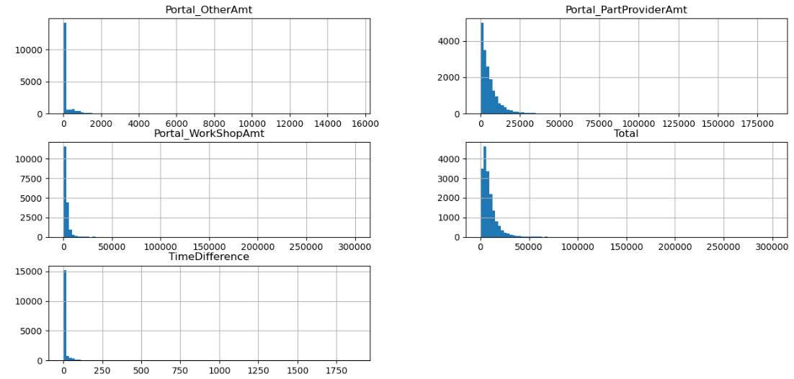

* The above figure shows the Distribution of the Total Claim Amount and all other Related Amount.
* All Amounts Distributions are Skewed to the Left.
* So based on this, I have classified the Claims into different Categories.
* Other Amount :- Class 1 : value = 0, Class 2 : value = (1 - 2000), Class 3 : value > 2000
* Workshop Amount :- Class 1 : value = 0, Class 2 : value = (1 - 25000), Class 3 : value > 25000
* Time Difference :- Class 1 : value = 0, Class 2 : value = (1 - 14), Class 3 : value > 14
* Parts Provider Amount :- Class 1 : value = 0, Class 2 : value = (1 - 25000), Class 3 : value > 25000
* Total :- Class 1 : value = 0, Class 2 : value = (1 - 50000), Class 3 : value > 50000

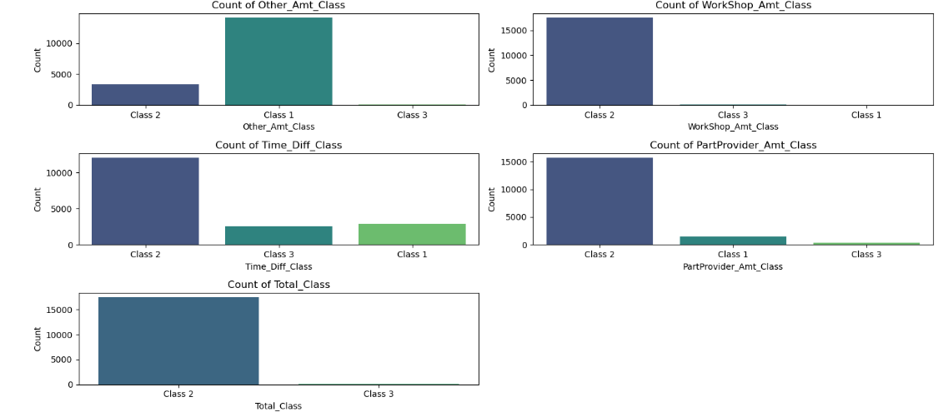

* Given the Class Distribution above.
* **Other Amounts** : Class 1 - 14095, Class 2 - 3396, Class 3 - 72, ie Only in 3400 cases the Other Amount is Given, All other Cases other Amount is Zero.
* **Workshop Amount** : Class 1 - 22, Class 2 - 17490, Class 3 - 51
* 90% of the values of Workshop Amount Lies between 1 – 25000.
* Only 51 is more than that, and 22 cases workshop amount is Zero.
* **Time Difference** : Class 1 - 2909, Class 2 - 12055, Class 3 - 2599
* 12000 Claims are Processed in two weeks, and 2900 cases are processed in same day.
* 2600 cases are taken more than two weeks.
* **Parts Provider Amount** : Class 1 - 1492, Class 2 – 15734, Class 3 - 337
* In 15734 claims, the Parts Provider Amount is between 1 – 25000.
* 1500 cases there is no parts provider amount and 337 cases have higher values.
* **Total** : Class 2 - 17474 , Class 3 - 89
* More than 90% belongs to Class 2 which is 1 – 50000.
* Only 89 cases have a higher Total Claim amount which is greater than 50000.

**Bivariate Analysis**

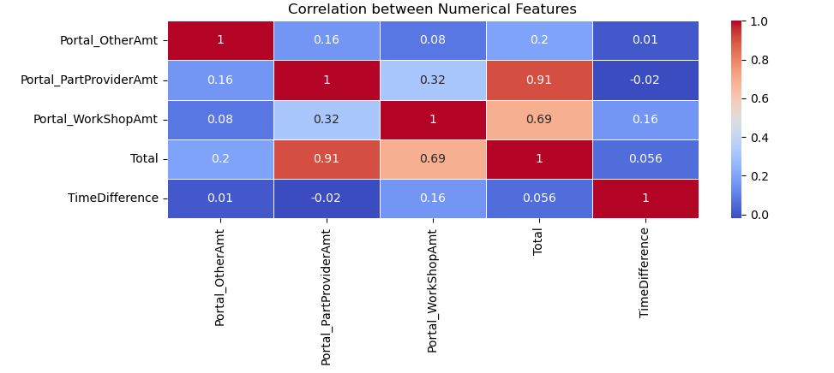

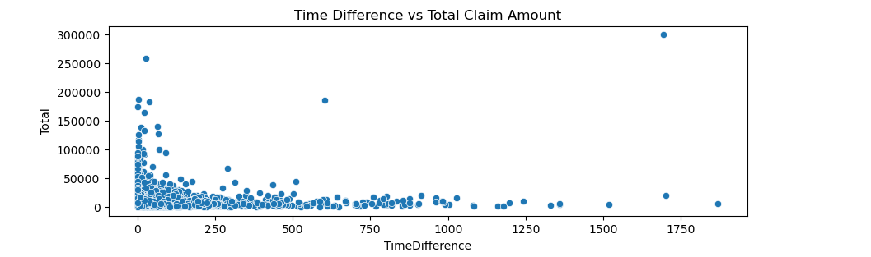

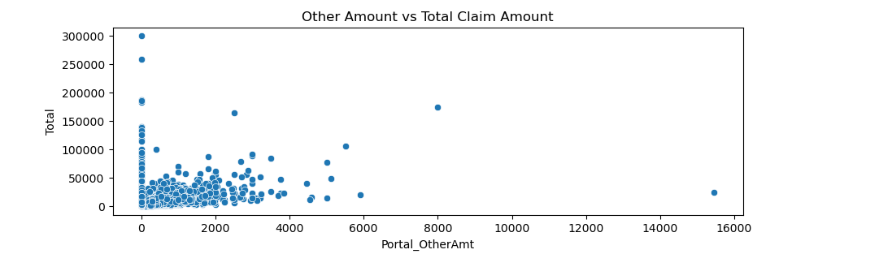

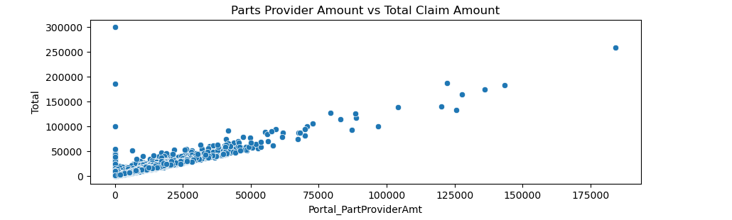

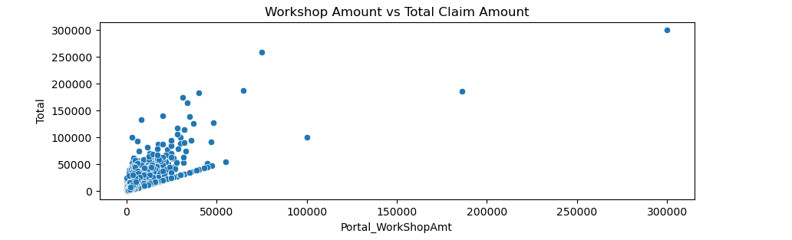

* Relationship between the features
* By the Correlation matrix and Scatter Plot Analysis.
* Portal_PartProviderAmt and Total (0.91): Strong positive correlation, indicating that part provider costs significantly influence the total claim amount.
* Portal_WorkShopAmt and Total (0.69): Strong positive correlation, suggesting workshop costs also impact the total claim, though less than part provider costs.
* Portal_OtherAmt and Total (0.2): Low positive correlation, showing that additional costs have a minor effect on the total claim amount.

**Outlier Detection**

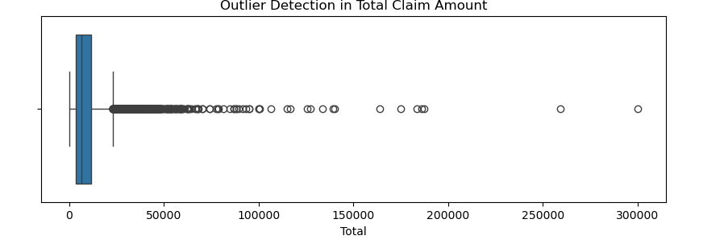

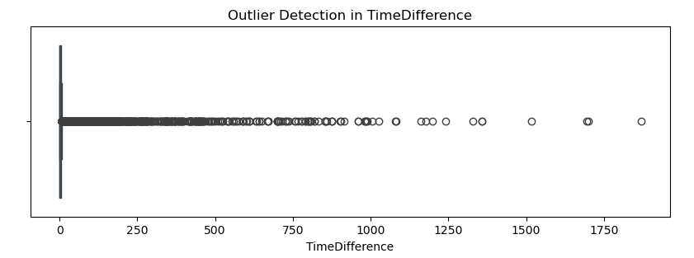

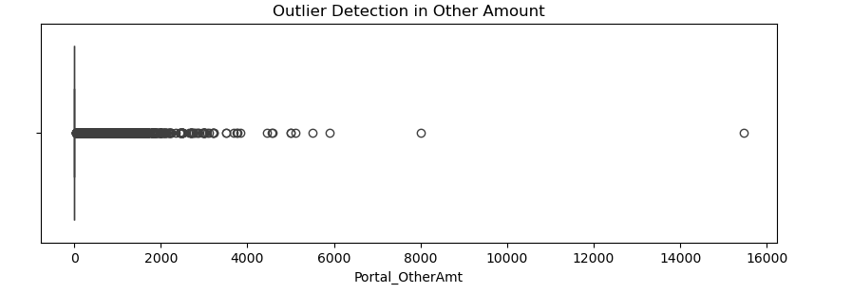

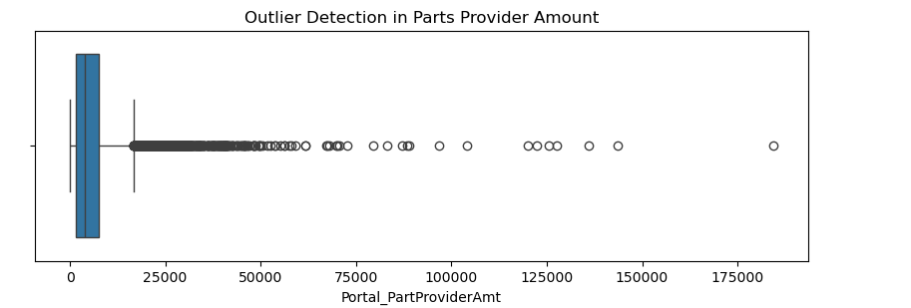

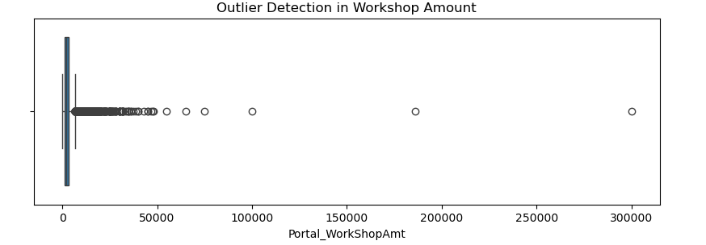

* Here all the Numerical Data Values are Skewed.
* All Data values are mostly centred around the Zero to a Normal Value.
* From that, there are high amount of Outlier Values in the Data.

**Analysis Overview:**

* Total Number of Claims: 17,563 claims were processed.
* Average Processing Time: Claims are processed in an average of 16 days.
* Total Claim Amount: The total claim amount is approximately 156,998,699.
* Total Parts Provider Amount: Claims for parts providers total around 101,537,100.
* Total Workshop Amount: Workshop-related claims amount to 53,106,254.
* Other Amount: Miscellaneous claims contribute 2,355,345 to the total.

Claim Analysis by Vehicle Make:

* Top Claim Amount**:** Toyota leads with the highest claim amount (44,719K), followed by Hyundai (36,184K).
* Number of Claims**:** Toyota also has the highest number of claims (5.1K), with Hyundai following closely (4.8K).
* Claim Processing Time**:** Scania has the longest average claim processing time (290 days), followed by Sedan (130 days).

Claim Analysis by Vehicle Model:

* Top Models by Claims: Camry and Elantra are the most claimed models, with 1.77K and 1.37K claims, respectively.
* Claim Processing Time: SL500 has the longest average processing time (179 days), followed by Landcruiser Pickup (178 days).

Claim Analysis by Accident Place:

* Top Locations for Claims: Riyadh has the highest claim amount (71,346K) and the most claims.
* Other Significant Locations: Jeddah is the second-highest with 16,699K in claim amounts.

**Class 2 of Total Amount: ie, Amount between 1 – 50000**

* Total Number of Claims: 17,474 (out of 17,563 total claims).
* Average Processing Time: Claims in this category are processed in an average of 16 days.
* Total Claim Amount: Approximately 149,696,095, contributing significantly to the overall total.
* Total Parts Provider Amount: 96,680,662, reflecting high parts-related claims.
* Total Workshop Amount: 50,724,754, indicating substantial workshop costs.
* Other Amount: 2,290,679, showing minor additional costs.

**Contribution Analysis:**

* Number of Claims: Class 2 constitutes approximately 99.5% of all claims.
* Total Claim Amount: Contributes about 95.6% to the total claim amount (149,696,095 out of 156,998,699).
* Parts Provider Amount: Represents around 95.2% of the total parts provider amount.
* Workshop Amount: Accounts for 95.5% of the total workshop amount.
* Other Amount: Contributes roughly 97.3% to the other amount total.
* **Top Claim Amounts:** Toyota and Hyundai continue to lead in claim amounts, with a slightly lower contribution compared to overall figures.
* **Number of Claims:** Majority of claims from Toyota (5.1K) and Hyundai (4.8K) fall into Class 2.
* **Claim Processing Time:** Vehicles such as Sedan and Cherry show longer processing times, similar to the overall data.
* **Top Models by Claims:** Camry and Elantra are the most frequently claimed models within Class 2, indicating consistent damage patterns.
* **Claim Processing Time:** Models like Space Star and Haval H6 show longer average processing times, even within this specific claim class.

**Class 3 of Total Amount: ie, Amount above 50000**

* Total Number of Claims: 89 claims fall under Class 3.
* Average Processing Time: Class 3 claims take significantly longer to process, with an average of 40 days compared to the overall average.
* Total Claim Amount: 7,302,604, which is a much smaller portion compared to Class 1 and Class 2.
* Total Parts Provider Amount: 4,856,438, reflecting higher part costs per claim.
* Total Workshop Amount: 2,381,500, indicating that workshop costs are substantial for each claim in Class 3.
* Other Amount: 64,666, which is a minor contribution, but potentially significant given the smaller number of claims.
* **Number of Claims:** Class 3 constitutes only about 0.5% of the total number of claims.
* **Total Claim Amount:** Contributes approximately 4.7% to the total claim amount.
* **Parts Provider Amount:** Represents around 4.8% of the total parts provider amount.
* **Workshop Amount:** Accounts for roughly 4.5% of the total workshop amount.
* **Other Amount:** Contributes about 2.7% to the other amount total.
* **Top Claim Amounts:** High-end brands like Mercedes and BMW have the highest claim amounts in this class, indicating expensive repairs.
* **Number of Claims:** Mercedes leads in the number of Class 3 claims, followed by BMW and Porsche.
* **Claim Processing Time:** Scania vehicles take the longest to process claims, at an average of 290 days.
* **Top Models by Claims:** Cayenne and Actros models have the most claims in this class, reflecting high repair costs for these specific models.
* **Claim Processing Time:** The GLE43 model has an extraordinarily long processing time of 1,694 days, indicating possible complications in claim resolution for this model.

**Recommendations:**

**Speed Up Claim Processing:**

* **Identify claims that take the longest to process and find ways to make them faster.**
* **Automate repetitive tasks like document checks to save time.**

**Control Costs:**

* **Keep a close eye on high-cost claims to avoid unnecessary expenses or fraud.**
* **Negotiate better deals with parts suppliers and workshops to reduce costs.**

**Detect Fraud Early:**

* **Look for patterns in expensive claims that might indicate fraud.**
* **Use data analysis to flag suspicious claims early on.**

**Improve Customer Service:**

* **Keep customers updated about their claim status to build trust.**
* **Create a fast-track process for frequent claimants to handle their cases quicker.**

**Optimize Operations:**

* **Train staff on effective claim handling and customer interaction to improve service quality.**
* **Allocate more resources to busy areas like Riyadh and Jeddah for better claim management.**

**Strategic Focus:**

* **Pay special attention to high-risk areas and vehicle models that often have high claims.**
* **Update policies to better handle high-risk situations and reduce overall costs.**

**Analyse and Reduce "Other Amount" Costs:**

* **Investigate what contributes to high "Other Amount" costs in claims.**
* **Identify unnecessary expenses and find ways to reduce them, such as improving internal processes or negotiating better rates for these additional costs.**